Weekly Work Report 11/15/2024

**This Week:**

* **Literature review**

Shin, Y., Choi, D., Park, H., Lee, M., Hong, T., & Koo, C. (2024). Impact of Heat Stress on Individual Cognitive States: Utilizing EEG Metrics in Immersive VR–Based Construction Safety Training. *Journal of Management in Engineering, 40*(6), Article 6076. <https://doi.org/10.1061/JMENEA.MEENG-6076>



The theta/beta ratio (TBR) in the frontal area is inversely related to attention control and serves as a key biomarker for its assessment. Theta/beta ratio recorded from frontal regions was considered a valuable biomarker of attentional control, indicating a negative relationship with attentional control.

**Individuals with higher theta/beta ratios tended to have lower attentional control.**

Employed unsupervised learning via **K-means** clustering to categorize training EEG signals into three distinct clusters, each representing a different level of attention. (training, exam(experiment))

2 clusters? Print the mean, std, in each cluster for 2 or 3 clusters

Training: Attention

Exam: Relax

Distribution of ratio in Training and Exam dataset

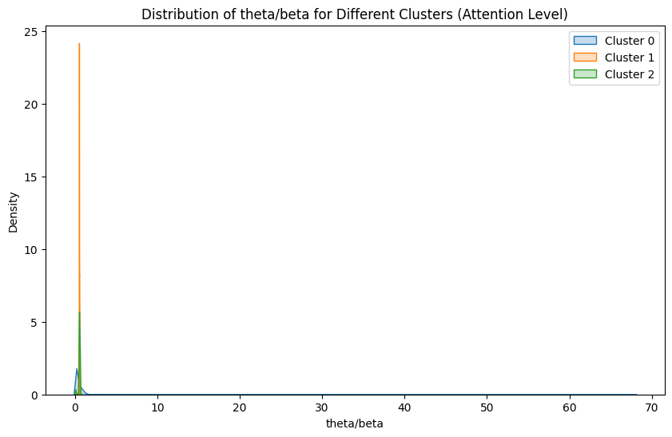

**Features**

* power of frequency bands + **'theta/beta'**
* ['delta', 'theta', 'sigma', 'beta', 'mid_beta', 'high_beta', 'low_gamma', 'theta/beta'] Attention, same models
* ['delta', 'theta', 'sigma', 'beta', 'mid_beta', 'high_beta', 'low_gamma'] Attention, same models
* Compare these two result by using same models, same dataset with 'theta/beta' and without 'theta/beta'

**Labels**

* **0: Baseline, 1: Impasse, 2: Aha, 3: Attention**

**Feature extraction:**

freq_bands = {

**'delta'**: (0.5, 4),

**'theta'**: (4, 8),

'alpha/mu': (8, 12),

'low_alpha': (8, 10),

'high_alpha': (10, 12),

'mu': (9, 12),

**'sigma'**: (12, 16),

**'beta'**: (13, 30),

'low_beta': (13, 15),

'**mid_beta'**: (15, 20),

'**high_beta'**: (20, 30),

**'low_gamma'**: (30, 50)

}

# Sample rate (adjust as needed)

fs = 125

def calculate_band_power(eeg_signal, freq_bands, fs):

band_powers = {}

for band_name, (low_freq, high_freq) in freq_bands.items():

# Apply FFT to the EEG signal

fft_values = np.fft.fft(eeg_signal)

frequencies = np.fft.fftfreq(len(eeg_signal), 1/fs)

# Find indices corresponding to the frequency band

idx_band = np.where((frequencies >= low_freq) & (frequencies <= high_freq))

# Calculate the power in the frequency band

power = np.sum(np.abs(fft_values[idx_band])**2)

band_powers[band_name] = power

return **band_powers**

**Aha:**

Impasse

1. Finishlist.csv
   1. **'finishClick'**with Selection: **A (stuck)**
      * From **bt_finish_click_time – 15** to **bt_finish_click_time – 5**
      * 10s

**Attention**

* High attention from k-means clusters derived from **training** EEG signals
* Filter?

**61 subjects**

**Result KNN**





FCCN

ROC Curve

* RF

1. XGBoost

**Next Week:**

* Complete processing of additional signals, including EDA and pupil data.
* Utilize the **Spectrogram** approach to convert EEG signals into 2D images and extract spectrogram features.
* Consolidate all information and present results in a single table.
* Compare findings to other research papers using the same dataset.
* Analyze different time windows (1s, 3s, 5s, 8s) based on literature review.
* Another ROC, imbalanced dataset

**This Month:**

* Compare Aha!/Impasse/Attention classification using
  + physiology signals
  + EEG
  + physiology signals + EEG

**Final Goal:**

* Explore the dynamics of **Attention**, **Impasse**, and the **"Aha!"** moment.